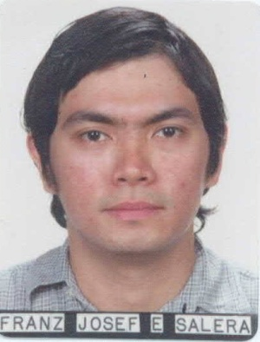

FRANZ JOSEF E. SALERA
#0905 Acacia St., Pajo, Lapu- Lapu City
TEL # 340-80-49 / CELL # 09329260862
franz.salera@gmail.com

OBJECTIVE
Applying for the position of copy editor

SKILLS
- Communication - Proficient in both spoken and written English and it’s usage
- Knowledgeable in the use of Microsoft Word, Powerpoint, Excel, Office and other similar applications as well as most transcription platforms; familiar with the use of the internet; above average typing speed; one-touch transcriptionist and proof reader
- Team player, flexible , open minded, dedicated, honest, detail oriented

EDUCATIONAL BACKGROUND
COLLEGE
XAVIER UNIVERSITY, BS COMPUTER SCIENCE 2001-2002
Cagayan de Oro City

LICEO DE CAGAYAN UNIVERSITY, ASSOCIATE IN HEALTH SCIENCE AND 2002-2004
Cagayan de Oro City EDUCATION (AHSE)

LICEO DE CAGAYAN UNIVERSITY, BS NURSING 2004-2006
Cagayan de Oro City

SECONDARY
CORPUS CHRISTI SCHOOL, 1997-2001
Cagayan de Oro City

ELEMENTARY
CORPUS CHRISTI SCHOOL, 1989-1997
Cagayan de Oro City

WORK EXPERIENCE
CUSTOMER SERVICE REPRESENTATIVE
Convergys Banawa ( Sprint Account)
October 05, 2009 – February 27, 2010

MEDICAL TRANSCRIPTIONIST
Acusis Philippines (formerly SPi Global)
May 9, 2011- November 30, 2013

REFERENCES
1. Mrs. Delia V. Realista
Clinical Coordinator ( Liceo de Cagayan University)
Tel # : (088) 857-1580
Cell # : 09275295911

2. Mr. Vincent Labininay
Clinical Instructor ( Liceo de Cagayan University)
Cell # : 09174746095

3. Ma. Catherine Serrano
Team Leader ( Convergys)
Cell # : 09173285283

